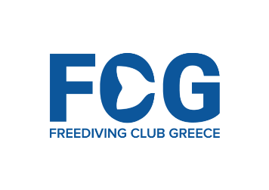

Registration Form

Please fill in all fields marked with _________ and return this document to us at least by 15th August 2023 to reserve your place. If you do not have all information please send us the information you have at this time and resend the form when you have the rest of the info.

Personal Information:
NAME: __________________ FAMILY NAME: ________________
NATIONALITY: ____________ DATE OF BIRTH: ____/___/_______
E-MAIL ADDRESS: _________ PHONE NUMBER: ________________

Arrival Information
Arrival Date in Kalamata: __________ Details of arrival: _________ (Airport of Arrival)
Departure Information
Departure Date from Kalamata: ________________

Competition Fees 6th CMAS Freediving World Cup Outdoor
- Competition Week early bird discount – book by 1st August 2023 €500
- Competition Week late booking 2nd August to 15th September 2023 €595
- Last minute booking Competition Week after 16th September 2023 €675
- Official Training Week (official training starts Sept 7th) €300/week
- Official Training Day (official training starts Sept 7th) €70/day

* Options
- Post dive decompression O₂ (5-8min @ 5m after diving) €25/week

- Training Week consists of 7 calendar training days with morning dive sessions. We provide transfers, safety, warm up lines, counterballast main lines and evacuation setup.

Accommodation
We have arranged special Competition Rates at Elite Resort Hotel (4*) on the beachfront of Kalamata - please contact us for additional info.

All training & competition fees are payable during freediver’s arrival & registration on the 1st day of their arrival at the event.

A non-refundable (for cancellations without a serious medical reason, or cancellations during the 4 weeks prior to your arrival) registration deposit of 50% of your total fees is required to confirm your booking.

Will you be requiring O2 decompression during your training with us (the cost for decompression oxygen is €25 per week)? YES / NO
Your deposit will be deducted off your participation fees at the time of registration. Please email us a confirmation of the transfer of the deposit after it has been completed (info@freediving-club.gr)
Have you sent the registration deposit? YES / NO

By submitting this registration form you agree to all terms and conditions as described in this document and on the event webpage.

Deposits must be sent to the following account:
Bank Details:
Bank Name : Revolut
Account holder: Stavros Kastrinakis
IBAN: LT383250046239759705
BIC : REVOLT21

When sending your accommodation deposit please include YOUR NAME on the bank transfer.
* Any costs mentioned in this document refer to costs shared by all participating freedivers in order to cover the running costs and expenses of the event.

See you all in the Calm Zone

Stavros & Freediving Club Greece Team

